Servers:

|  |  |  |
| --- | --- | --- |
| **Server name** | **Source File Directories** | **Working/output Directory** |
| Development server | /home/dsi/.. | /t |
| Parallel server | /home/test | /z |
| Production server | /home | /d |

Default working directory - /home/<username>

We can only execute /t/test_<username>.sh

Run command in:

Dev server - ssh rht “sh –x /t/test_<username.sh>” 2>&1|tee <log_file>.log

Parallel server - ssh rhs2 “sh –x /t/test_<username.sh>” 2>&1|tee <log_file>.log

Environment Variable –

**DEV SERVER:**

export home_ins=/home/dsi # /home variable for insert file

export home_master=/home/dsi # /home variable for the master folder that contains all our scripts and programs

export d_dir="/t" # folder to hold all data files generated during processing

export home_ctr="/home/dsi" # /home variable for control file

export home_keep="/home/dsi" # /home variable for keep folder where we store files that need to be saved and used multiple times

export home_env="/home/dsi" # /home variable

export base_dir="/t/afp" # root folder for afp files

export keep_dir="keep" # keep folder

export database="test" # database assigned

**Dev server –** ( we cannot directly put file here , need to check in except insert file)

Processing script - /home/dsi/master/ (e.g. .sh,.pl)

Control file /home/dsi/control/ (e.g. .control)

Insert file /home/dsi/insert (e.g .ins)

DFA /home/dsi/isis/docdef/ (<name in capital letter>.dfa)

Project(.prj file) /home/dsi/isis/project/ (<name in capital letter>.prj)

Pseg /home/dsi/isis/pseg (e.g. .300 )

OVL /home/dsi/isis/ovl300 (e.g. .ovl)

**Check -in in Dev Server-**

1. Put your resources (those you want to check in) into /d/is/development/ronyD



(e.g. if I want to check –in test_script_rony.sh )

1. Login as testmain username – testmain password - DSItestmain$
2. Check in command - ssh -t rht "/home/master/dsi_dev_checkin.pl <username>"

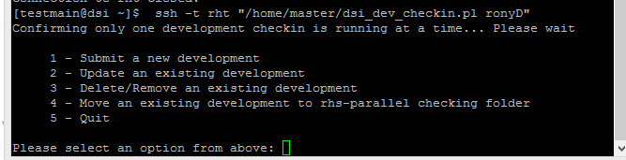

1. Use option 1 to submit /check-in

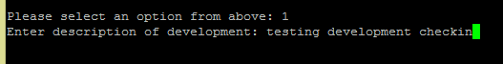

1. Press enter and you are done. If everything goes well you will be given an development id for this check-in by which you can access existing development . Resources will be put into correct directory automatically.

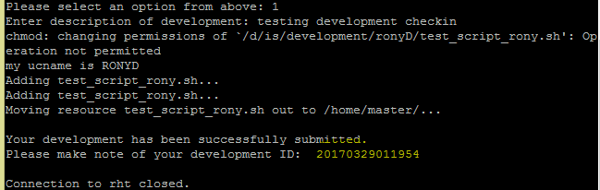

**See reports in dev- server:**

1. Login as testmain username – testmain password - DSItestmain$
2. **ssh -t rht "/home/master/dsi_dev_report.pl"**

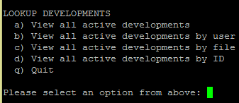

1. **Select any option you like and give appropriate argument.**

(e.g. if I select option c)

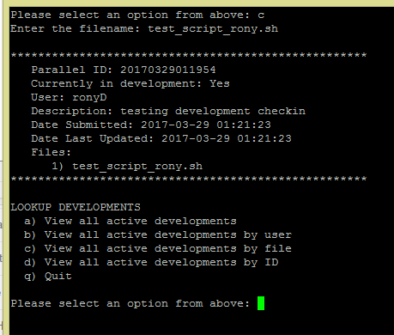

Check out from production:

1. Write this command in /t/test_<username>.sh

${home_master}/master/dsi_cvs_co.pl <username>

1. Run it –

sh /t/test_<username>.sh



Enter filenames separated by spaces and press enter, you are done

**Some Additional Directory**:

AFP to PDF:

${d_dir}/pdf_afp/${cid}/${prefix} /pdf

/afp

/zip